* OEMs
  + Distinction
  + OEM Specific Tasks
* Losses Definitions
  + Logics
  + Tables
  + Sequence
* APM Frontend
  + Tools, Libraries, Logics
* APM Backend
  + Infrastructure
  + Logics
* Live Signals
  + Signals
  + Source
  + Access method
* Database
  + Infrastructure
  + Source
  + Connectivity Schemes
* Meta Data
  + What it is?
  + Tables
  + Methods
* Support Services
* KEPServer
* WinCC
* Email Apps
* Meter Reading Apps
* IIS Management
* Server Management
* Archive Reports
* Mobile Application

## OEM:

## It is a turbine manufacturer varies by facility. The status displayed on the dashboard adheres to the guidelines set forth by the OEM.

## DATABASE:

### All data is contained within AlgoAPM, with two exceptions sourced externally: a. Status b. Live Data

### Data updates occur every 10 minutes, and the archive is stored within AlgoAPM.

### Steps to Run APM:

1. Deploy the server on the client’s premises.
2. Establish physical connectivity to enable data access based on the OEM's specifications.

Instead of using a traditional database, leverage OPC (Open Platform Communication) to retrieve data every second. This data is then averaged, and the processed information is run on AlgoAPM with a resolution of 10 minutes.

### APM Tables:

#### DeviceName:

SELECT * FROM DeviceName WITH (NOLOCK)

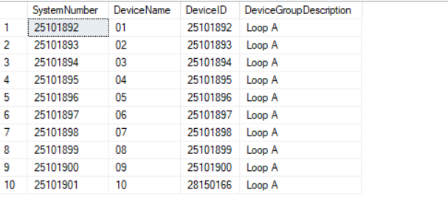

The **SystemNumber** serves as the unique identifier for the turbine. It is sometimes defined by the OEM; otherwise, AlgoAPM assigns a default sequence of **16152695**.  
The **DeviceName** corresponds to the turbine number.

1. Tbl_10MinCalender:

SELECT TOP 10 * FROM Tbl_10MinCalendar AS mc

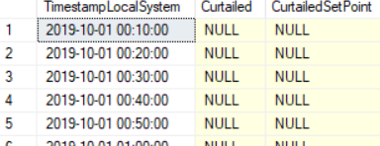

This is a metadata table that we populate manually. It is used to maintain and manage the custom calendar of AlgoAPM.

1. SELECT TOP 10 * FROM Tbl_10MinDeviceCalendar AS mdc

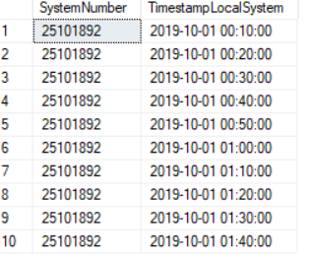

This table is the CrossJoin of the SytemNumber and Tbl_10minCalender.

Similarly we have Tbl_DaysCalender.

SELECT TOP 10 * FROM Tbl_DaysCalendar AS dc

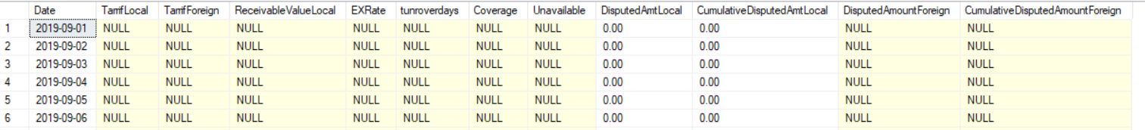

#### SELECT * FROM [System] AS s

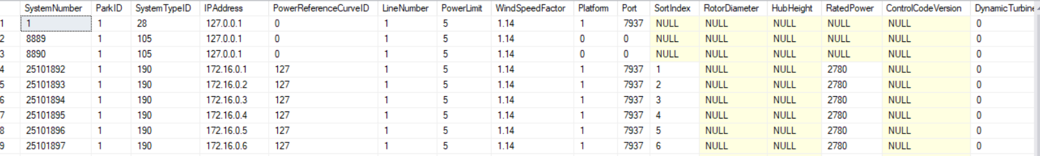

SystemtypeID is used to differenciate among the type of Turbines

#### SELECT * FROM PowerReferenceCurveValues AS prcv ORDER BY CurveID, prcv.WindSpeed

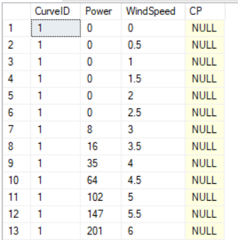

#### The CurveID represents the curve corresponding to a turbine's maximum capacity. The relationship between power and wind speed is cubic, with power plotted on the y-axis and wind speed on the x-axis. At extreme wind speeds, the turbine is disabled to prevent runaway conditions.

#### Tbl_OpsYear:

SELECT * FROM Tbl_OpsYears AS oy

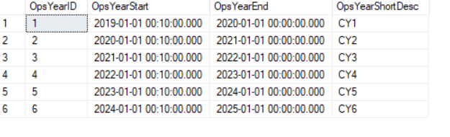

The "Ops Year" refers to the Operational Year, which begins when AlgoAPM starts receiving data from the client turbine.

#### Tbl_fiscal:

Similar to operation year we have the table for fiscal year which starts from 1st July (year eg 2021) and ends at 30th June (year e.g 2022).

#### Tbl_curtailmentdetails:

The is the derived table having the points where the plant was curtailed.

#### Tbl_GridDetails:

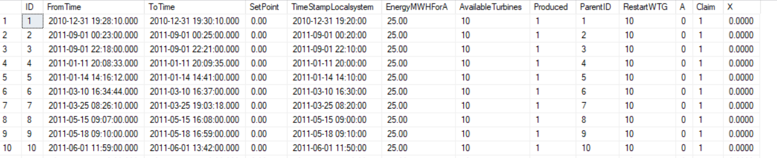

These are the points where the curtailments was issued by Grid(where we have to send the power).

1. Tbl_MenuPages:

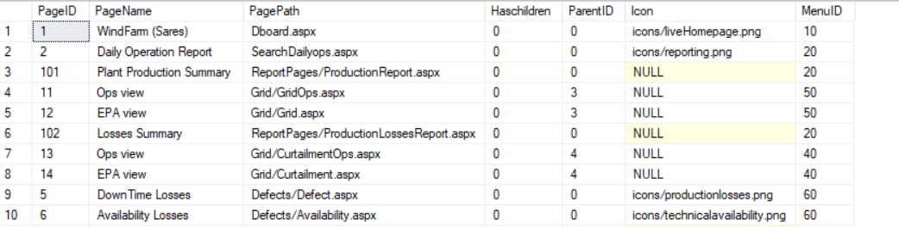

#### These pages are related to the user and define which page should be displayed in specific contexts.

#### Tbl_Users:



This table has the credentials, password is encrypted.

#### Tbl_userpages:

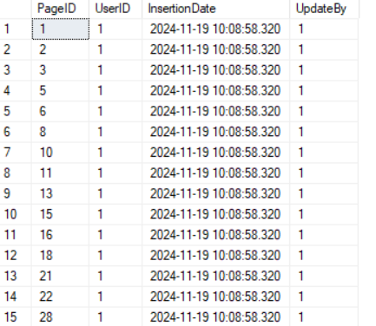

This has the details of the page which a user can see.

#### Tbl_Plant:

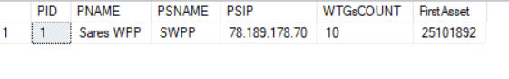

This has the details of the particular plant whose connection is running. WTGsCOUNT is the number of turbines the plant has. FirstAsset is the first system Number.

Similarly we have the Tbl_PlantDetailsfornotifications , logoTable.

#### Tbl_windreference:

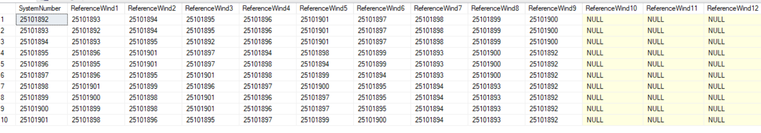

This table has the reference of the turbine next to it. When a turbine becomes off and the data is not available the data from the nearest reference is captured. Later on this data is used to calculate the loss of the turbine (ie loss=Expected Power - Produced Power)

#### Tbl_winddirbin:

SELECT * FROM Tbl_WindDirBin

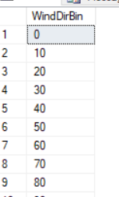

This is having the wind direction with 10min interval.

#### ZTable:

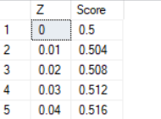

This is the probability table and if the points are plotted it gives a Gaussian curve. The data in the table is static. Used in PM algo and wind resource assessment.

#### Tbl_Tempbin:

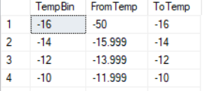

This table is similar to the tbl_windbin having bin values where a particular range of the temperature drops.

#### Tbl_Temperatures:

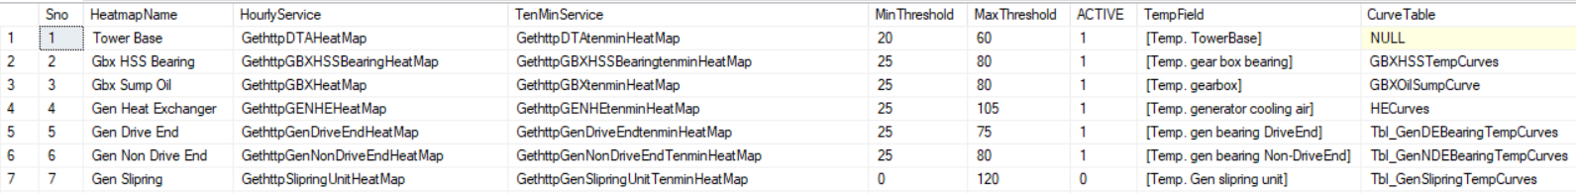

The tempfield is the metadata.

Similarly, the tbl_reportkeyword, Glossary are the meta data tables.

We need the meta data powercurve , turbine position , Plant IP, port, wind , location and date to start a turbine.

#### Tbl_historian:

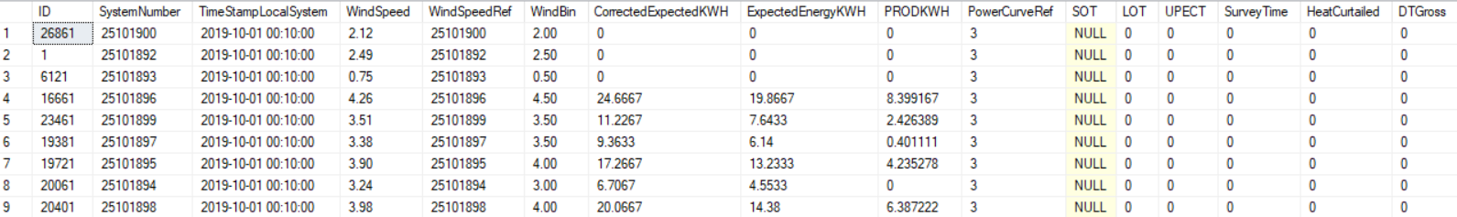

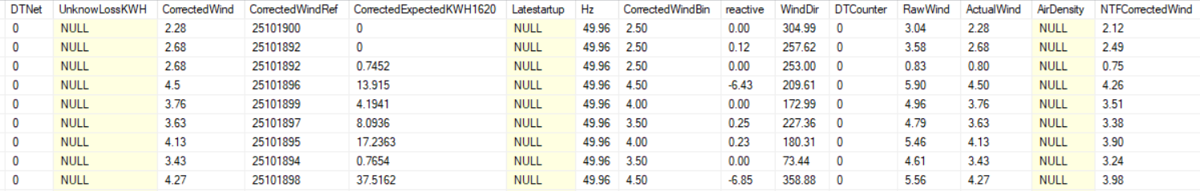

### This table is one of the most crucial components of the database, as it contains detailed information about all the turbines recorded at 10-minute intervals. Since the plant comprises 10 turbines, the data for a specific timestamp, such as October 1, 2019, at 10:00 AM, is repeated 10 times—once for each turbine. This pattern applies to all other timestamps as well. Auto generated field is ID. The fields SystemNumber and TimeStampLocalSystem are derived from Tbl_10MinDeviceCalendar.

### Curtailments/ EPL(External power loss):

These are the rules by govt or client to degrade the performance of the turbine in certain situations.

### IPL:

Stands for Internal power limitations which could be caused within the turbine for instance the temperature of gearbox goes up so we have to stopping/slowing down the turbine.

### Downtime loss (DT):

This is the duration of time when the turbine is off. This can be caused due to windspeed, power or direction.

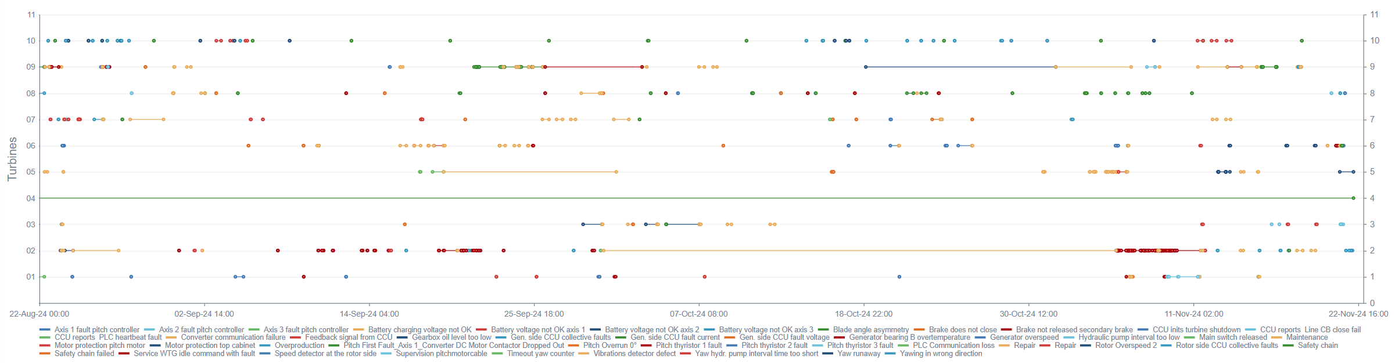

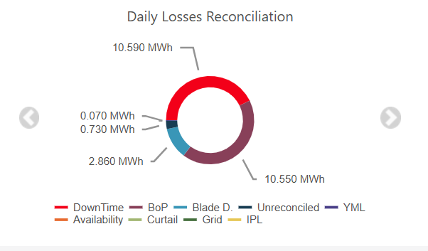

### Availability:

This concept is similar to *Downtime Loss*, but there is a subtle distinction between the two. Let’s clarify with an example:

The manufacturer guarantees that the turbine will operate 95% of the time. The remaining 5% may involve periods when the turbine is offline due to specific events such as turbine testing or maintenance. These events, known as *availability events*, are excluded from the availability calculation and are not considered availability.

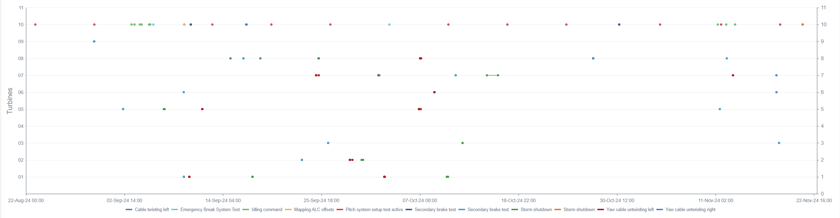

These are the availability event which will not comprise of the 5% relaxation.

### BoP (Balance of Plant):

This is the difference between the produced energy and delivered energy by the plant.

BoP = (Produced- Delivered) energy

### YML (Yaw misalignment losses):

Yaw misalignment is when a wind turbine is not facing directly into the wind, which can cause a loss of power and revenue.

### Power Curves:

Power curves describe the relationship between wind speed and power output and are often provided by the Original Equipment Manufacturer (OEM). These static graphs are a tool aimed at addressing underperformance by predicting how much power a turbine should generate at different wind speeds.

#### OEM PC:

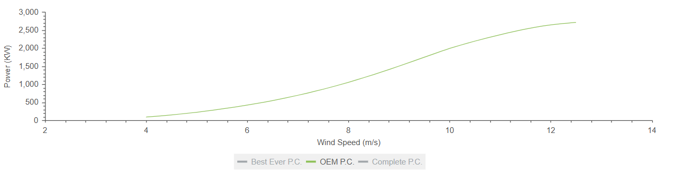

Here is an example of the OEM curve.

#### Best Ever PC:

This is the graph of historic data plots of the max power produced by plant.

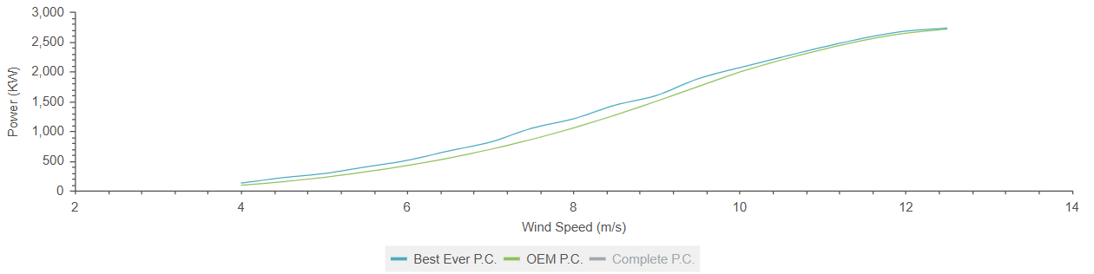

#### Actual PC:

This is the measure of actual power produced against the wind.

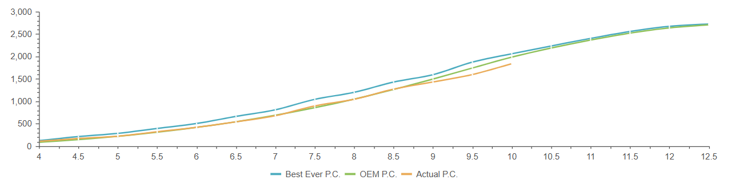

### Blade Deterioration loss:

### If the actual performance is lower than the best-ever performance, it may be attributed to contamination, leading to what is known as blade deterioration loss.

### Unreconciled loss:

The difference between the OEM power curve and best ever is counted as reconciled loss.